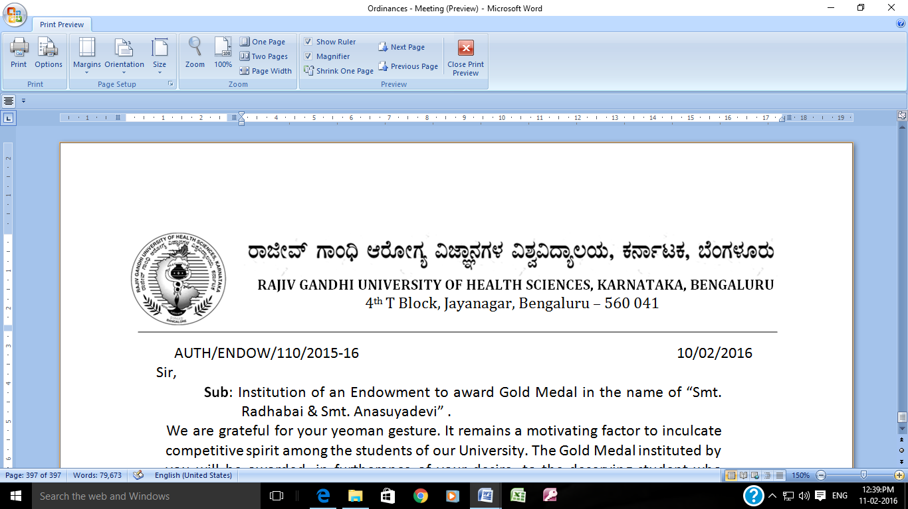

Dr. M K Ramesh, E-mail: [registrareva@rguhs.ac.in](mailto:registrareva@rguhs.ac.in)

Registrar (Evaluation) Ph: 080 – 26961930 Fax: 26961931,

R[E]/EXAM/Pharm/NOTI/UG&PG/Nov/Dec-2018 Dated: 24/11/2018

### REVISED NOTIFICATION

|  |  |
| --- | --- |
| Sub : | Conduct of B.Pharm / Pharm-D / Pharm-D [PB] & M.Pharm (Yearly), B.Pharm (Semester) & M.Pharm (Semester) Theory Examinations during November/December – 2018 |
| Ref : | 1. Revised Advance Notification No.: R[E]/Exam/NOTI/UG&PG /Nov/Dec – 2018, Dated : 05/10/2018. 2. R[E]/EXAM/Pharm/NOTI/UG&PG/Nov/Dec-2018, Dated:26.10.2018 |

~ ~ ~ ~

In continuation of this Office Notification cited above, the **B.Pharm / Pharm-D / Pharm-D [PB] & M.Pharm** **(Yearly), B.Pharm (Semester) & M.Pharm (Semester)** Theory Examinations will be held from **27/12/2018** respectively. The detailed Time table will be notified shortly.

|  |  |  |  |
| --- | --- | --- | --- |
| Sl.No | Faculty | Year | Exam |
| 1 | B.Pharm | I, II, III & Final Year | Yearly |
| 2 | Pharm-D | I, II, III, IV & Vth Year | Yearly |
| 3 | Pharm-D [PB] | I & II Year | Yearly |
| 4 | M.Pharm | I & Final Year | Yearly |
| 5 | B.Pharm – SS | I, II & III Semester | Semester |
| 6 | M.Pharm – SS | I, II & III Semester | Semester |

Schedule for compliance of the Institutions:

|  |  |  |
| --- | --- | --- |
| Sl. No. | Events | Dates |
| BP/PD/PB/MP, BP (SS) & MP (SS) |
| 1 | Launching of Application Form in rguhs Website | 21/11/2018 |
| 2 | Examination Fee – payment last date | 12/12/2018 |
| 3 | Payment of Examination Fee with Fine of `100/- upto | 17/12/2018 |
| 4 | Payment of Examination Fee with Fine of ` 200/- upto | 22/12/2018 |
| 5 | Application Forms : submission date (without & with fine) | 27/12/2018 |

**Page - 1**

|  |  |  |
| --- | --- | --- |
| M. Pharm – Dissertation Submission Dates | | |
| 6 | Last date for submission of Dissertation One Soft Copy (CD) only of M.Pharm Courses without fine. (Hard Copy not required) | 22/11/2018  before 5-00 PM |
| 7 | Last date for submission of Dissertation One Soft Copy (CD) Only of M.Pharm Courses with fine of ` 1,500/- per Candidate. | 27/11/2018  before 5-00 PM |

Fee details are as follows

|  |  |  |  |  |
| --- | --- | --- | --- | --- |
| Sl. No. | Particulars | **UG**  (B.Pharm, Pharm-D & Pharm-D PB) (Yearly) & B.Pharm (SS) | **PG**  (M.Pharm) – (Yearly) & M.Pharm (SS) |  |
| 1 | Examination Application form | ` 200 /- | ` 200 /- | To be paid by all the candidates |
| 2 | Marks Card | ` 300 /- | ` 300 /- |
| 3 | B.Pharm / Pharm-D / Pharm-D [PB] & M.Pharm Examination Fee per paper | ` 300/-  per paper | ` 1000/-  per paper |
| 4 | Provisional Degree Certificate | ` 600/- | ` 750/- |
| 5 | Fees for conferring degree in absentia  i. Indian Nationals  ii. Foreign Nationals  iii. SAARC Nationals | ` 2000 /-  ` 4000 /-  ` 4000 /- | ` 5000/-  ` 6000/-  ` 6000/- |
| 6 | Dissertation Fee | To be paid while submitting the Dissertation to the University.  ` 1000/- for M.Pharm courses. | | |

### Instructions to the Candidates:-

### Note:-

### Final year Candidates of all the faculties are required to pay the provisional degree certificate fee, and convocation fee along with the examination fee compulsorily.

### The students admitted under management quota and the repeaters, including SC/ST Category – I and other category candidates who have selected seat through CET have to pay the examination fee as shown above. (Ref: Latter No. Reg/Ex-II/SC/ST/BLM – 59/2003-04, dated 18/11/2003).

### The failed candidates (repeaters) need not pay the marks card fee of ` 300/- as already paid.

### The fee once paid cannot be refunded or re-adjusted under any circumstances.

### Change of Centre shall not be permitted.

**Page - 2**

#### Instructions to the Principals / Heads of Institutions

1. Attendance:

The Principals of Colleges are required to furnish attendance of all the candidates by calculating the attendance up to the last working day of course/term. There is no provision for condonation of Attendance.

2(a). SC/ST and Category - I candidates also have to pay the examination fee, as per the letter of Director of Medical Education No. MEH (3)/22/2002-03, dated 27/03/2003. Hence these students have to pay the examination fee as per the RGUHS Notification.

2(b). All Repeaters candidates including SC/ST/Category –I of all faculties are not exempted from the payment of exam fee. As per the Government letter vide No. SWL 229, BCA 80, dated 16/12/1982.

2(c). An amount of Rs. 200/- towards application form & Rs.300/- towards Marks Card be collected from the students appearing for Third Semester M. Pharm Course.

**3. Internal Assessment:**

|  |  |  |
| --- | --- | --- |
| Sl. | Particulars | BP/PD/P/MP (Yearly), BP – SS & MP – SS |
| a. | Last Date for filling Online of Internal Assessment marks (Statement of Internal Assessment Marks) (Regular & Repeaters). | 27/12/2018 |
| b. | Hardcopies of Internal Assessment Marks signed by the students and Frozen Copies of Online filled Internal Assessment Marks shall reach to the University on or before | 29/12/2018 |
| c. | Last date for submission of Hard Copy of Internal Assessment Marks with a Fine of ` 10,000/- | 31/12/2018 |
| d. | Last date for submission of Hard Copy of Internal Assessment Marks with a Fine of ` 20,000/- | 02/01/2019 |

Note:

1. The “I.A. Marks” sent (through online) after the above dates will be returned to the concerned colleges and the Principals are solely held responsible for the lapses on this behalf as per letter No. Ex - I/UE/IA/Marks/105/98-99 dated 21-12-1998.
2. Internal Assessments marks list should send in a separate cover by indicating IA marks on the cover to concerned Section along with the list updated in the online.
3. The Principals should send the filled examination application forms in the order of Examination–wise/Batch-wise/scheme-wise in a separate covers.

**Page - 3**

1. Candidate Stamp Size Photo should be uploaded while generating the Online Application Form through [www.rguhs.ac.in](http://www.rguhs.ac.in) under the link (Examination Section) College Activity portal.
2. Filled application forms should be signed by both the candidates and the Principal in the required places.
3. The Principal should verify all the filled application forms and should reach the Registrar (Evaluation) on or before the specified dates by insured post or submitted in person.
4. The Principals should pay the notified fees of all the eligible candidates through rguhs online gateway payment portal (<https://payments.billdesk.com/> MercOnline/rgu/MainPage.jsp?page=mysore) and enclose the acknowledgement of the online fee receipt showing the details of Names of the candidates, Register Numbers, Subject appearing and fee paid etc. “In triplicate”.

Separate statement may be sent for the candidates who have paid the fee with fine along with other details.

The Principal of the Institutions should submit the details of SC/ST and Category – I candidates who have selected a seat under CET quota enclosing the caste / income certificate of the parents along with form No. I & II. After verification the University will approve the names of the eligible candidates for the exemption of payment of examination fee and the same may be claimed by the Institutions from the Social Welfare Department or from the backward class and Minorities Department as per G. O. No. SWL 229/BCA/80 dated 16-12-1982.

The Institutions have to collect the examination fees from all the candidates including the SC/ST/Cat-I candidates whether seat is selected under management or Govt. quota and remit to the University vide circular of RGUHS dated 22-11-2004.

The University will not claim the examination fees from the social welfare, backward class and minorities Dept. / Corporation.

The Institution should not collect Examination fees from the Ineligible candidate.

The Principals should send separate statements for Convocation Fee and Provisional Degree Certificate fee collected from the students who are appearing for the Final Year Examination with details such as Register Number, Name of the Candidate, Amount paid, and send the separate Online Transaction Receipts addressed to the Registrar (Evaluation).

**Page - 4**

Please notify all the University Communications especially the Examination Notification prominently on the Notice Boards of the institutions including hostels for the benefit of the students. Internal Assessment marks and attendance of the Students shall be displayed on the Notice Boards for the benefit of the students without fail.

Information is available at website [www.rguhs.ac.in](http://www.rguhs.ac.in)

By Order,

**Sd/-**

**Registrar [Evaluation]**

To:

The Principals of all the Pharmacy Colleges affiliated to RGUHS, Bangalore.

Copy to:

1. P.A. to Vice-Chancellor/Registrar/Finance Officer, RGUHS, Bangalore.
2. All the officers of the RGUHS, Bangalore.
3. Branch Manager, RGUHS Extension Counter SBM, Jayanagar, Bangalore – 41.
4. Asst. Registrar Regional center Belgaum, Gulbarga.
5. The System Analyst, RGUHS, Bangalore to host the same in the University Website.
6. QP Section / Guard File

**Page - 5**